**LP4 (Test on Edge Browser)**

**1.Verify the Header-**

(a) Logo should redirect to the correct link.

Logo is working fine, but it is redirect to the same website page.

(b) Logo link should open in a new tab.

Yes, Logo is open in new tab but redirect to the same webpage .

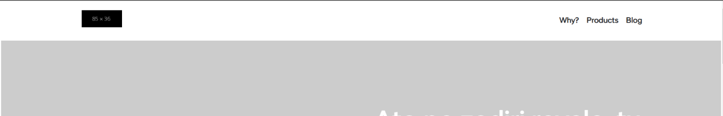

**2.Verify the Footer-**

(a) Verify redirection of Links and content.

All Link and Content is working fine but redirect to the same website page.

(b) Verify social icons' redirection.

All social icon is working properly, and it is open in new tab but redirect to the same webpage.



**3.Verify Correct Favicon- Favicon should be the same as it is on the client's live website.**

There is No Favicon on given website.

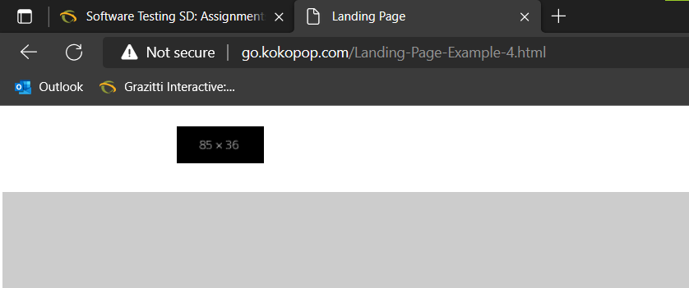

**4.Verify the Font-family- Verify font family is consistent throughout(unless special   requirement by client).**

**The font size of the paragraph is different from another paragraph. Set the front design as simple which is easy to understand for the customer or client.**

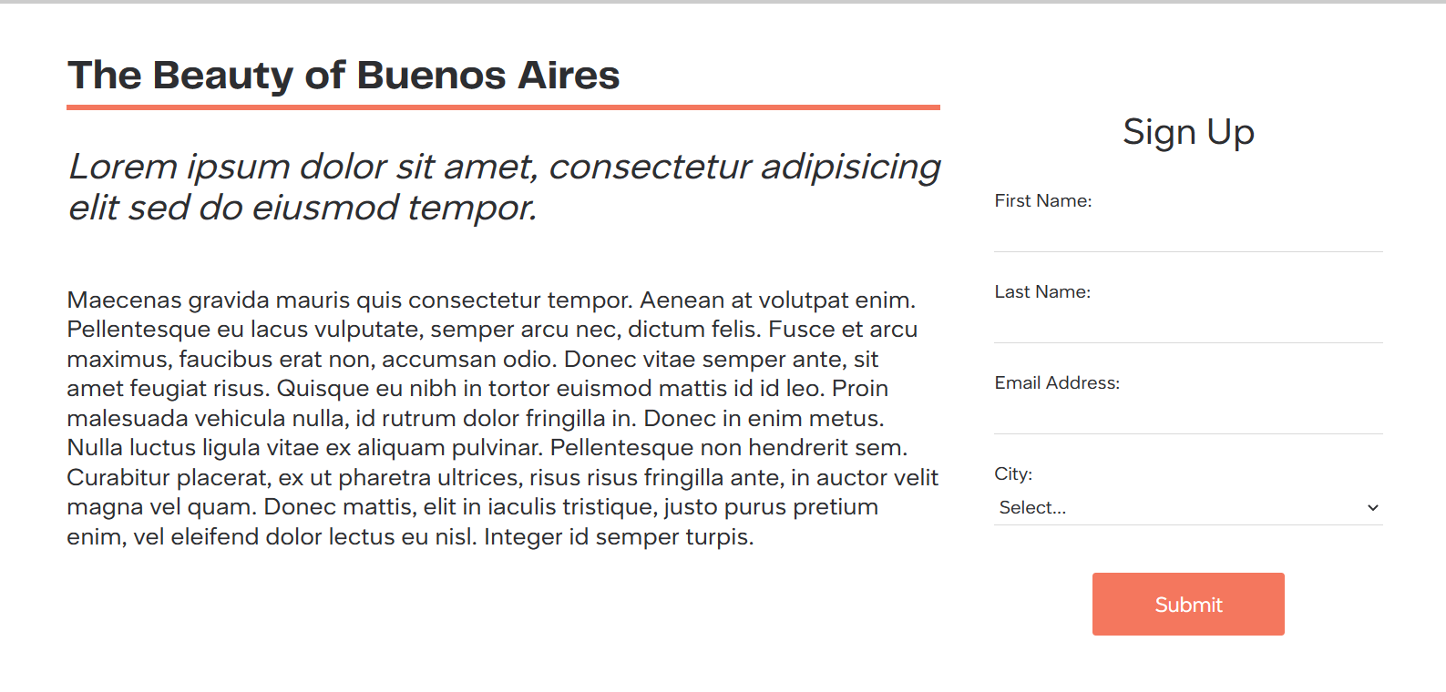

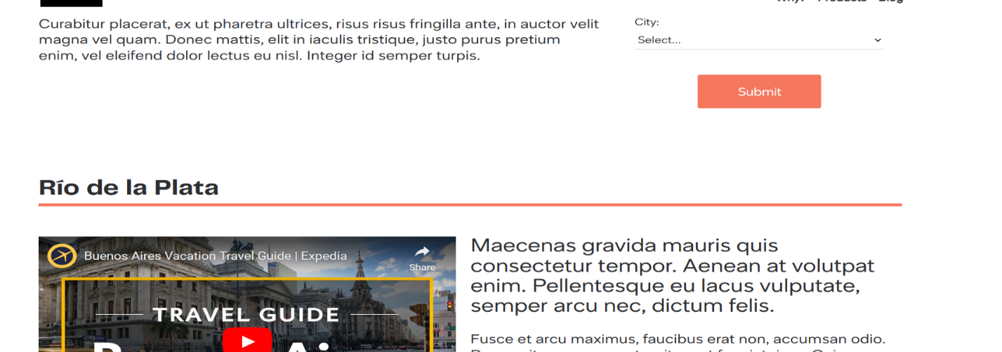

**5.Verify the redirection of links-**

(a) All CTAs, links and icons should redirect to correct pages.

Yes, all CTA and icons is redirected to the correct page, Submit button is not redirected to the other link.

(b) Add note to developer if # is used for links.

Remove the all ‘#’ from the end of the link.

**6.Verify the Spacing - Verify Spacing and alignment of the page should not break.**

Banner image is collapse with some heading content.



In this snapshot, there is too much spacing in the webpage and alignment of paragraph is also not correct .

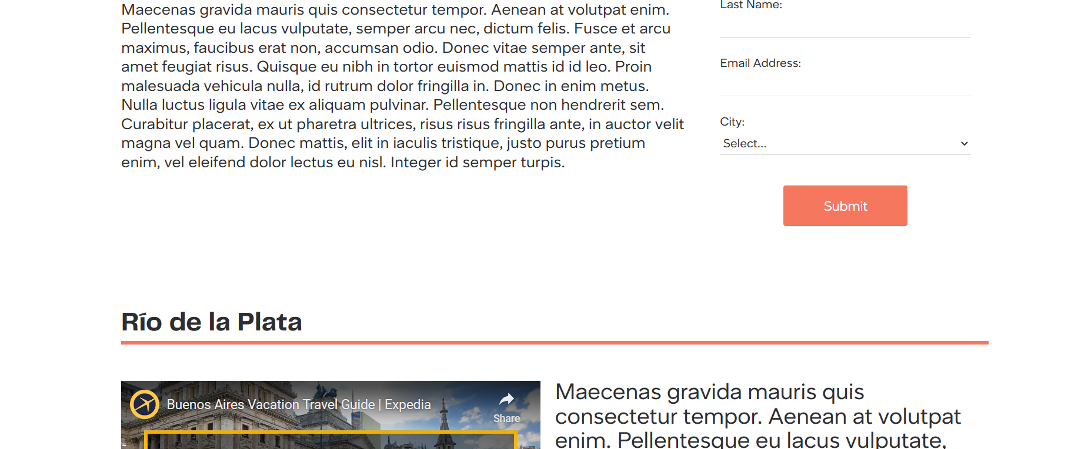

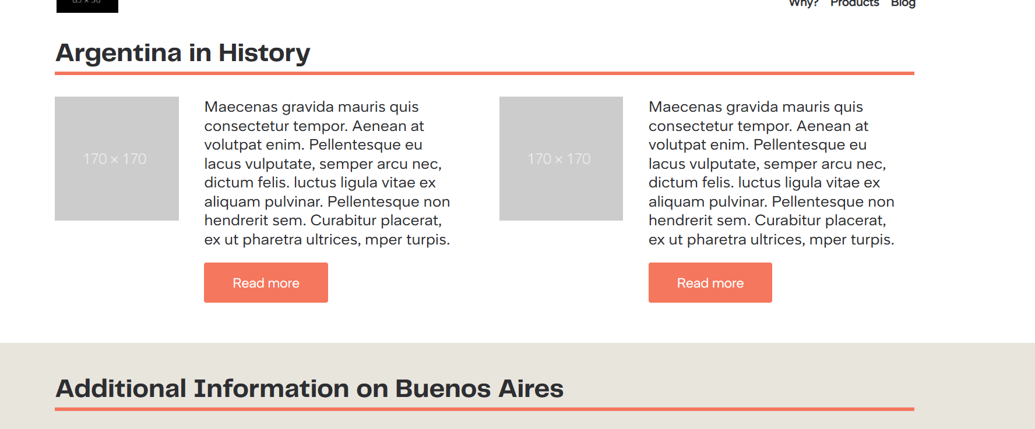

**7.Verify Form-**

(a) Verify alignment and spacing of form.

Alignment and Spacing of the form are correct.

(b) Verify * is used for Mandatory Fields.

* Is not Mandatory field for the given form.

(c) Verify it is showing correct error messages.

Not showing any error messages.

**8.Verify Thank you message after submitting form- If Required.**

When we click on SUBMIT button, there is no message shown as like Thank you.

**9.Verify Landing page on cross browsers- Google Chrome, Firefox, Internet Explorer and MAC (Safari).**

Working in Google, Chrome, Edge and Firebox

**10.Verify Responsive- Verify it on iPhone and iPad on simulator or live device.**